

Configuring VPN for
Palo Alto 220 Firewall

Rui Zhao, CCNA
Purpose:

The purpose of configuring VPN for the PA-220 firewall is to allow a network to access the internet at any location. Using VPN and integrating it with Remote Desktop allows us to communicate and control one device from one location to another.

Background Information:

Palo Alto Networks has founded the Cyber Threat Alliance with notable companies like Fortinet, McAfee, and Norton Life Lock in order to improve cybersecurity by sharing cybersecurity knowledge. They will soon have more members like Cisco, Check Point, Juniper Networks, and Sophos.

The Palo Alto PA-220 is a firewall that offers “Advanced Security at Scale” released by Palo Alto Networks. The firewall ensures security performance, threat prevention, and SSL decryption, meaning that customers can go onto the cloud without attacks coming from different environments like cloud network. The PA-220 series delivers full PAN-OS capabilities and is equipped with increased port density and a built-in resiliency via dual power adapters. The Palo Alto has also implemented noise cancellation and increased reliability, which must be ideal in small offices and remote places.

With the integration of Palo Alto’s VPN, namely called Palo Alto GlobalProtect, it provided a secure, encrypted remote access VPN that provides global access and secures traffic throughout any devices regardless of users, at any location. Equipped with security protocols and policies, it allows blocking and analyzing unwanted traffic in order to aid attacks such as cyberattacks, data breaches, malware, data leaks, and unauthorized access.

The GlobalProtect VPN is known for its enterprise-grade security, despite its relatively lower cost compared to other enterprise-grade architectures. Its performance compares to those of higher end firewalls and serves the same functions, offering tight security and control. Our initial configuration before configuring VPN features a SOHO configuration that features basic network control and access through our firewall.

GlobalProtect Portal is responsible for authenticating users and managing security protocols. This service manages multiple available gateways, allowing the ability for load balancing and regional access. The portal controls distribution and behaviors of the GlobalProtect software for both macOS and Windows endpoints and ensures safe connection regardless of location.

The GlobalProtect architecture matters because of how enterprises are advancing. With the uprising in civilization, cybersecurity has become a bigger concern for any companies due to the large equipment of attacks, such as DDoS, malware attacks, man-in-the-middle, or direct control. The Palo Alto firewall markets is one of the world’s leading industries for next-generation firewall products, making a huge footprint in the advancing cybersecurity world. With Palo Alto’s security tools, it supports multi-factor authentication, local user authentication, certificates, and audits all auditable logs necessary to resolve security issues.

Nonetheless, this service is not only for security reasons and for remote access at any given location but also scales extremely well too. Surprisingly, even with Palo Alto budget options, such as the PA-220, this firewall can support around a thousand users and supports load balancing for redundancy. This results in fault tolerance, scalability, budget friendly, and performance even during peak usage.

And Palo Alto isn’t stopping. They are constantly intaking network exploitations and learning cybersecurity attack patterns and constantly updating the firewall with new versions capable of negating the attacks. In this lab, we will demonstrate the GlobalProtect VPN configuration capable of these features with the integration of remote access from one place to another.

Lab Commands:

In order to configure the certificates necessary for the GlobalProtect configuration, we need to acquire our DHCP fetched IP address. Go to Network -> Interfaces -> Ethernet -> Dynamic-DHCP-Client

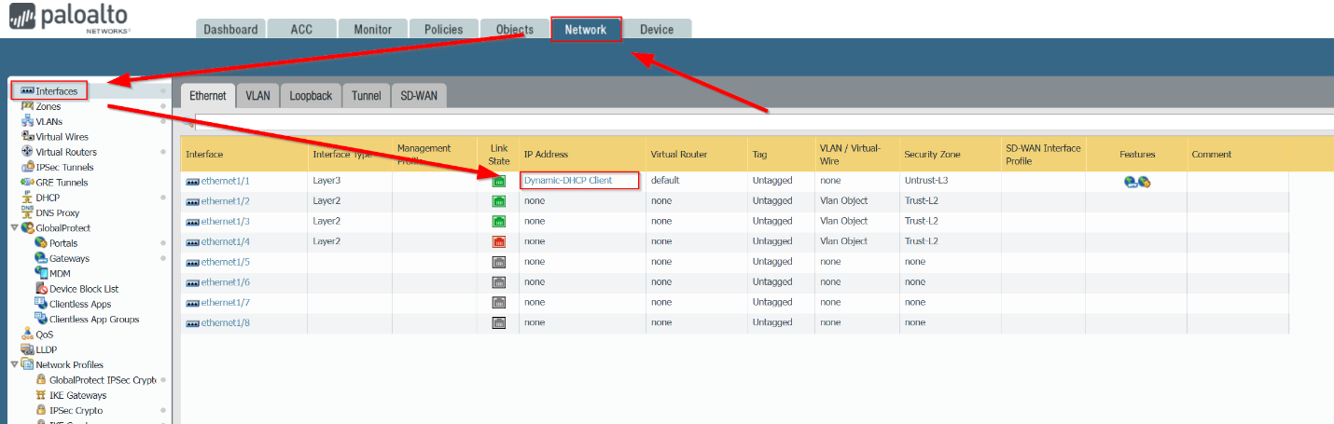

Then, go over to where it says 192.168.x.x and copy that DHCP IP address. This will be the IP address you will be using to make your server certification.

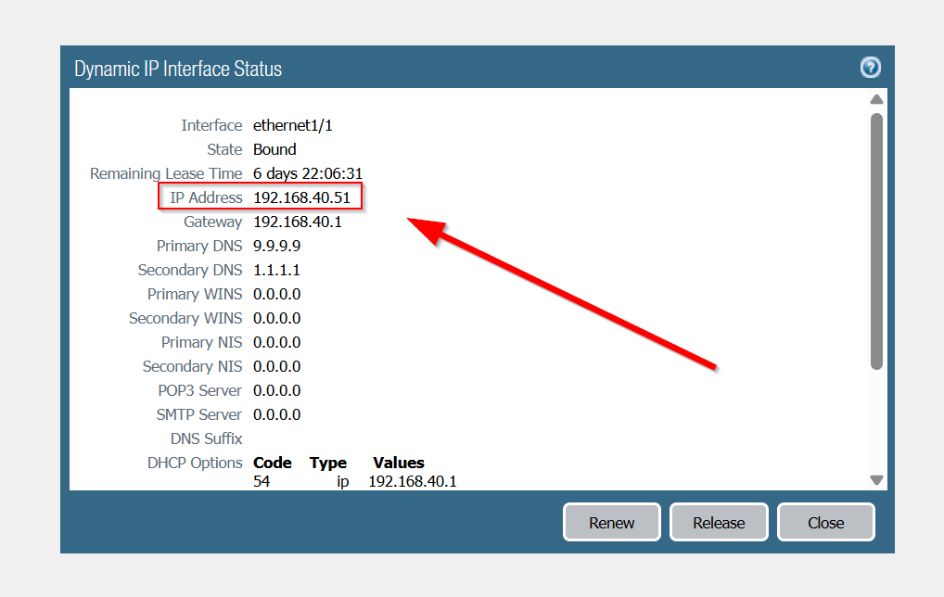

To make certificates, navigate to Device -> Certificate -> Add
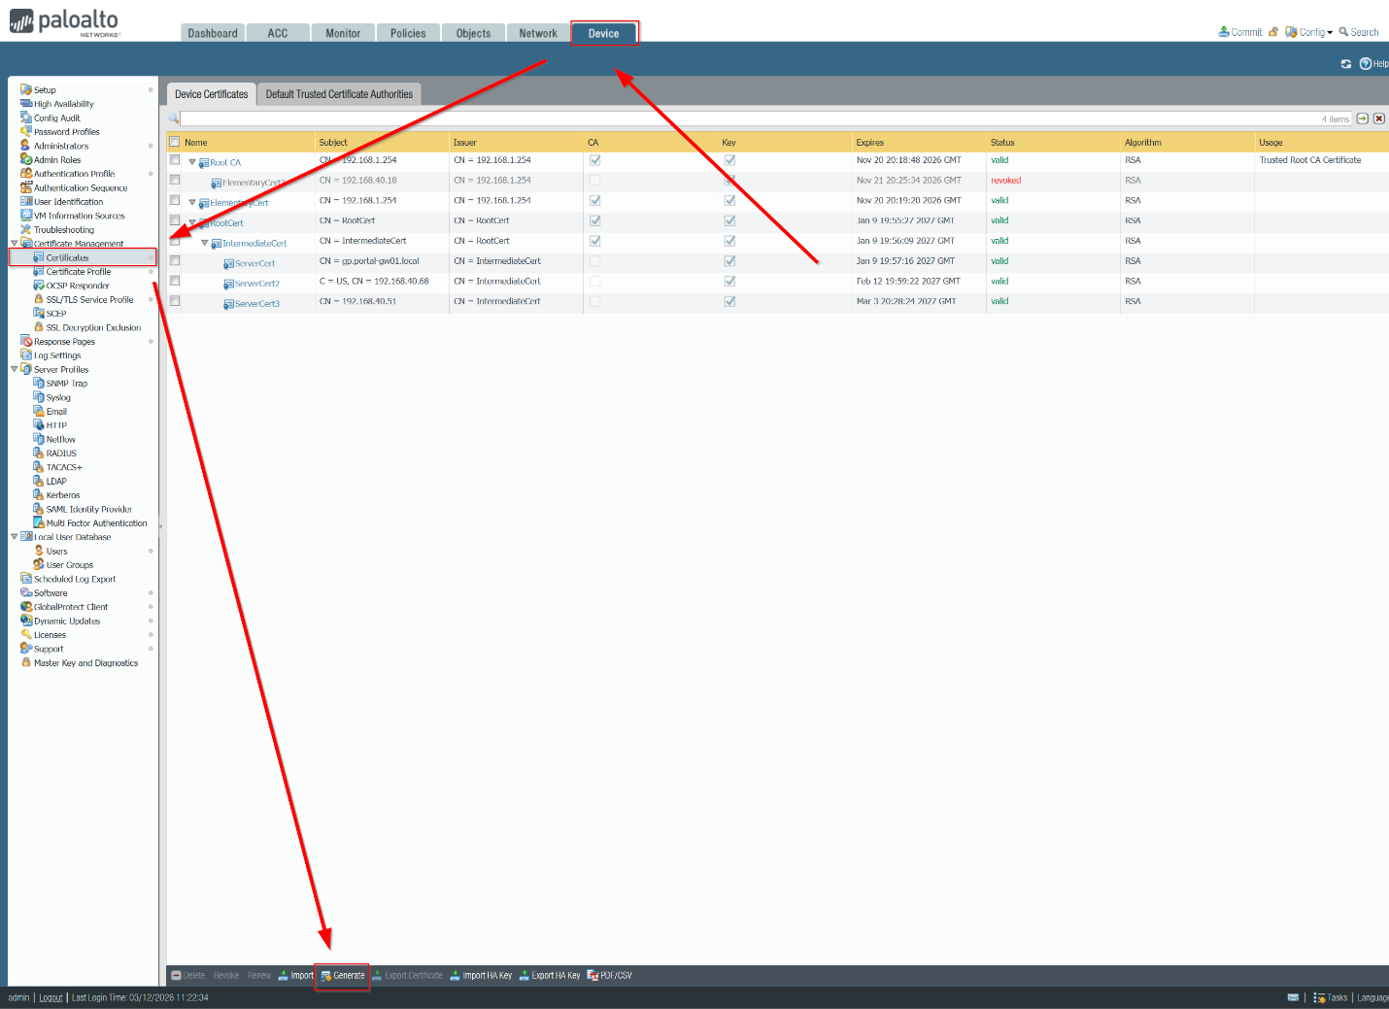

First, create the root certification. Make sure to check Certificate Authority to manage certificates through trusts for encrypted communications. Make sure you make them in order.
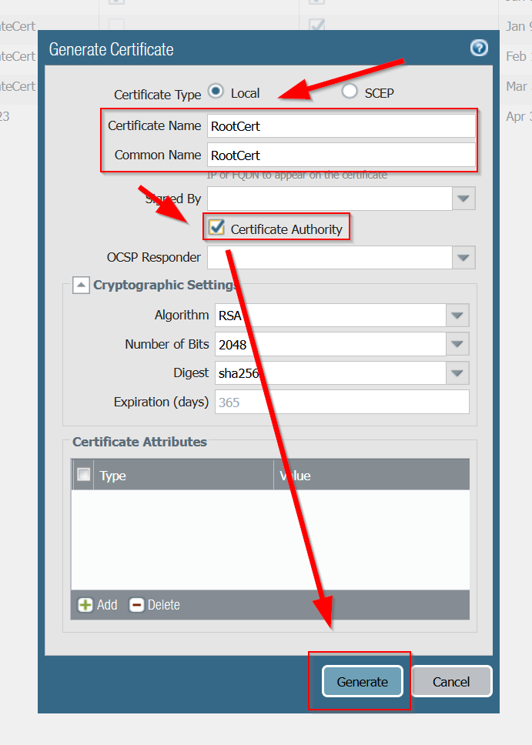
Next, make the Intermediate certification. Make sure it is signed by RootCert and check Certificate Authority for trust.
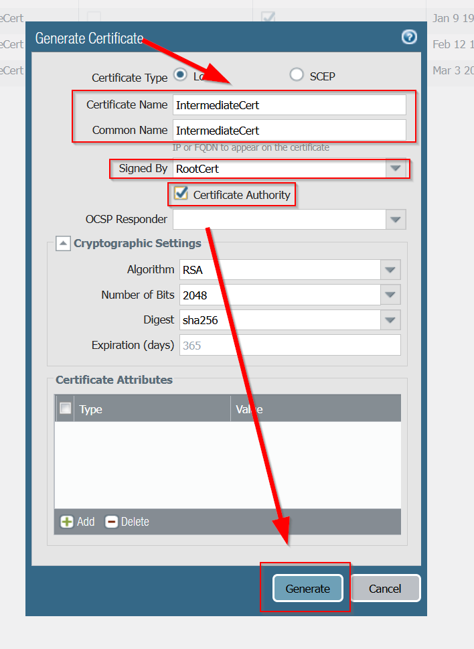

Finally, you will generate the server certification, signed by intermediate certification. Make sure not to check certification authority. For the Common Name, make sure to put your DHCP fetched IP address.
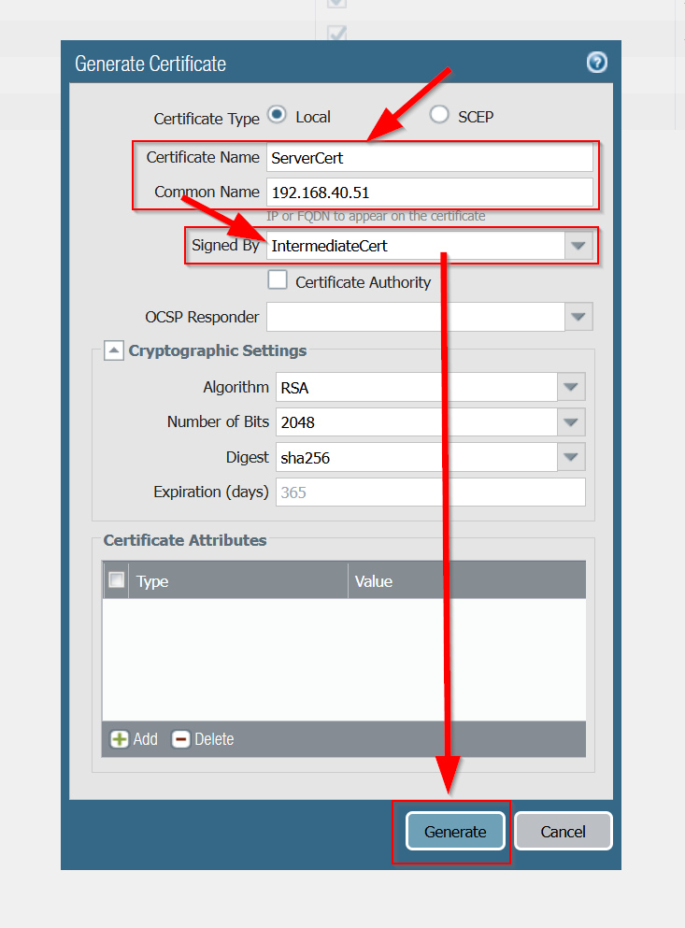

Finally, you should have this configuration. Note: If you unplug your ethernet cable from your firewall, your firewall will issue a new DHCP IP address. Make sure to make another ServerCert with the new DHCP IP address if that happens.

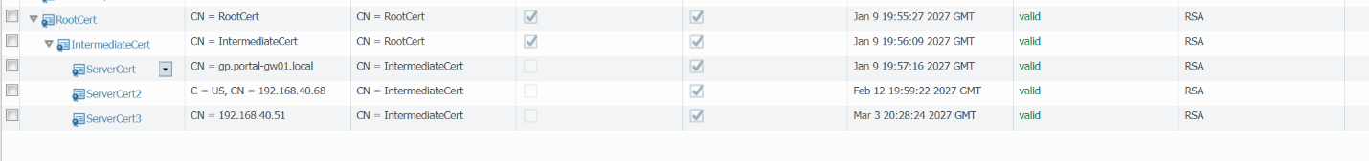

Next, to configure your SSL/TLS to encrypt data sent to ensure privacy and security. Head to Device -> Certification Management -> SSL/TLS Service Profile -> Add

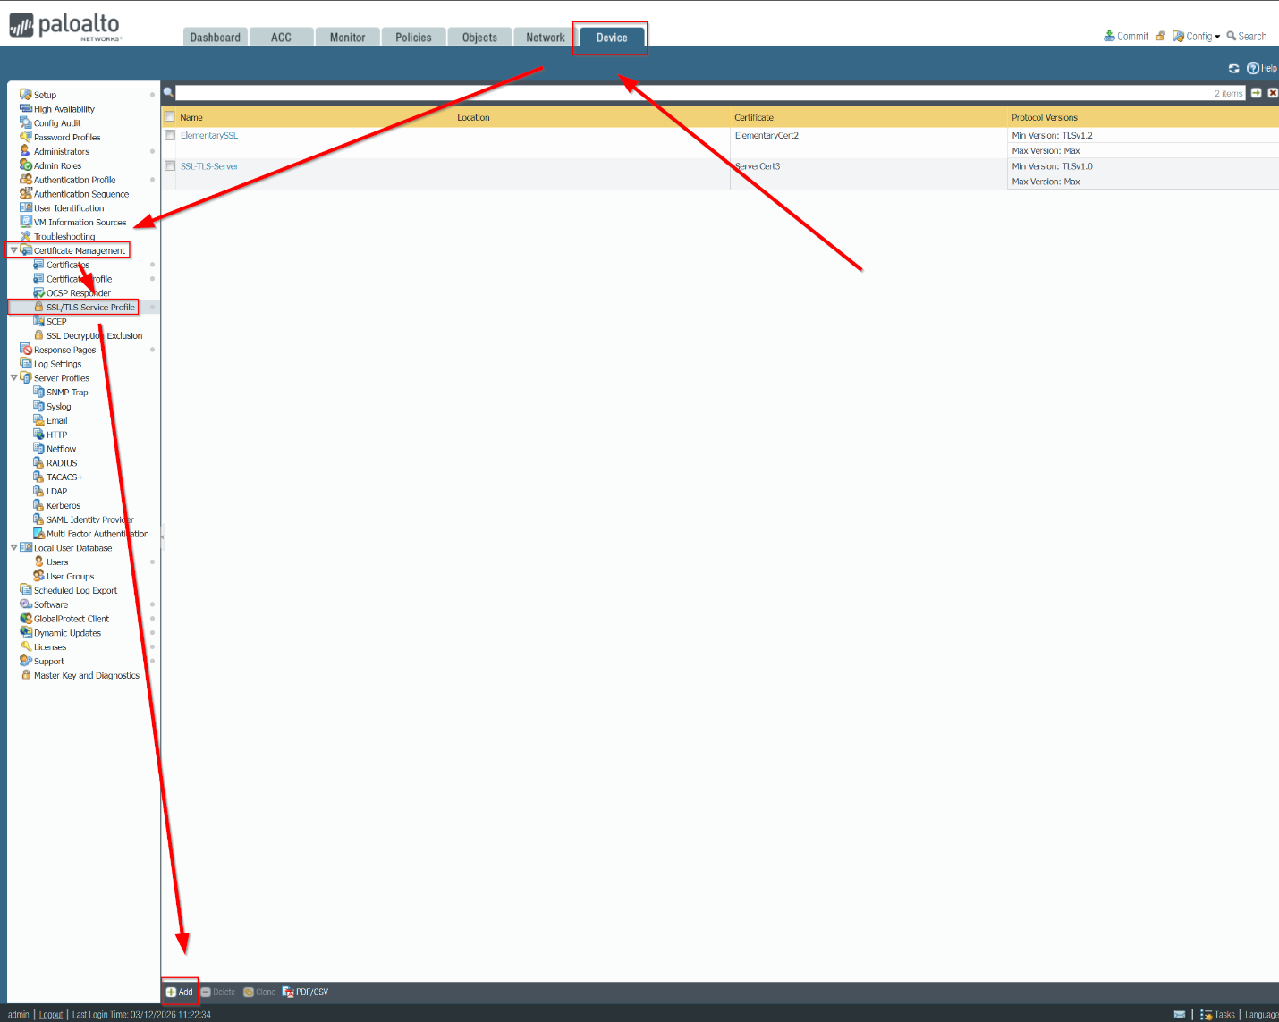

Configure SSL/TLS to these settings. Sign it with ServerCert and press OK.
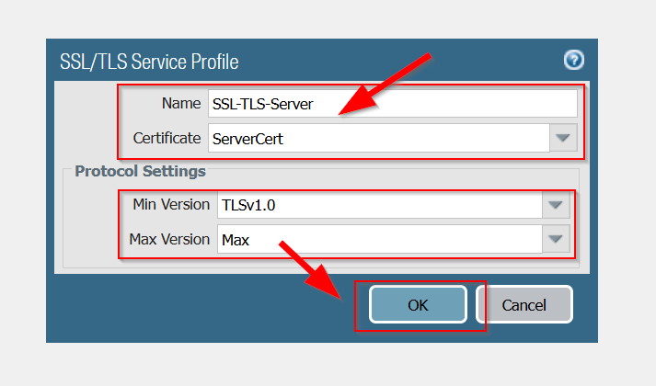

Then, to make a local user account, go to Device -> Authentication Profile -> Add.
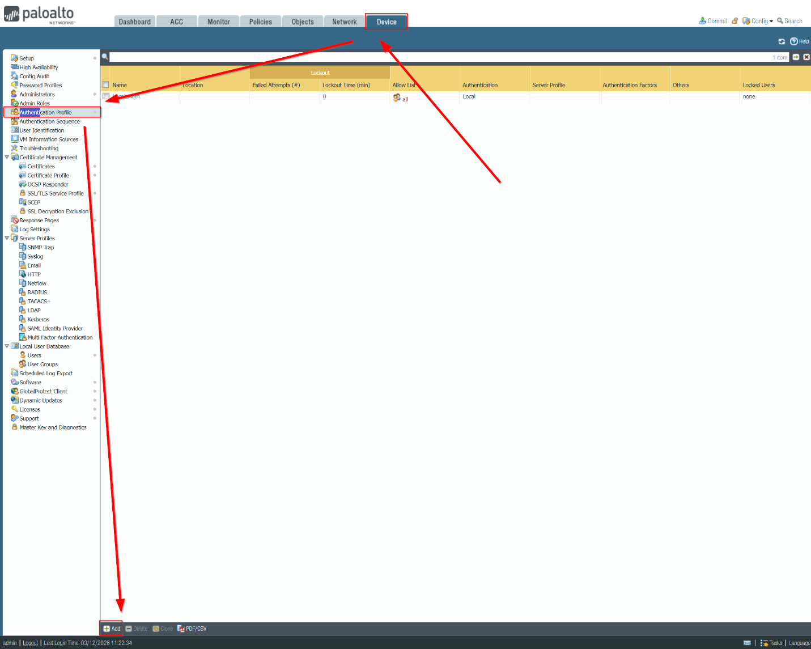

Fill in the name of the local account, set Type to Local Database and press Advanced to complete your local account.
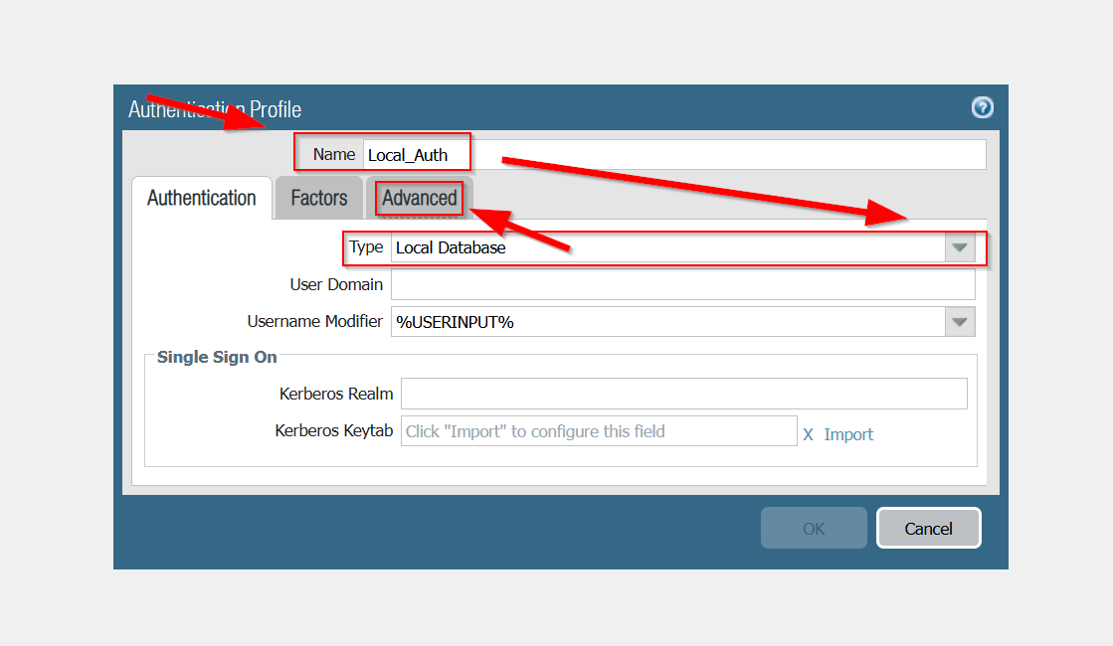

To configure the allow list, press Add -> Select all -> then finalize by pressing OK.
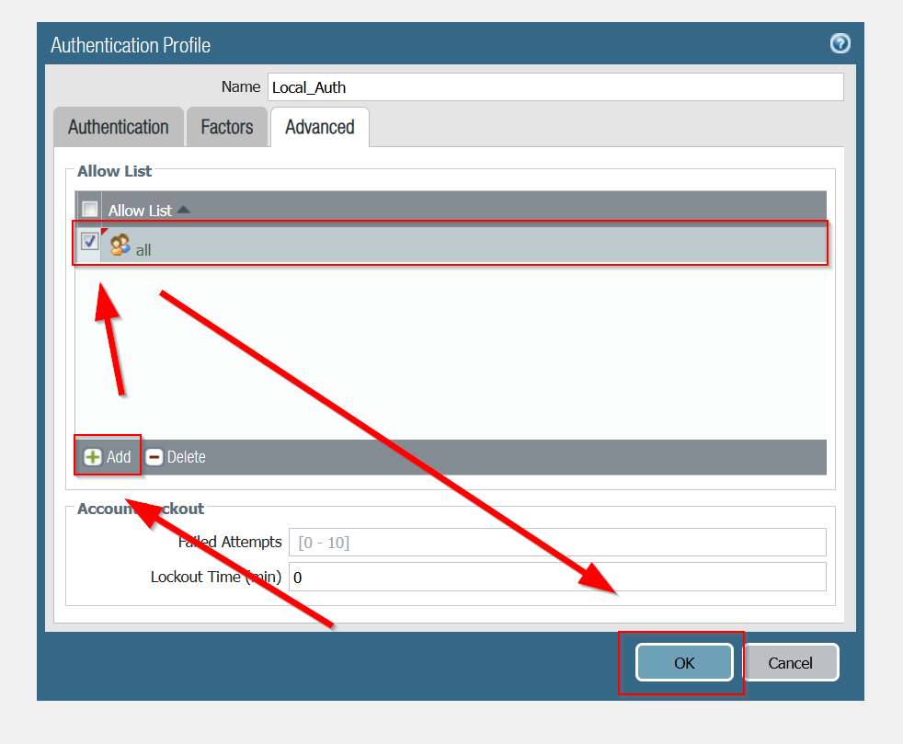

Next, in order to forward traffic to a segmented zone with boundary and traffic control, create a VPN zone. Go to Network -> Zones -> Add.
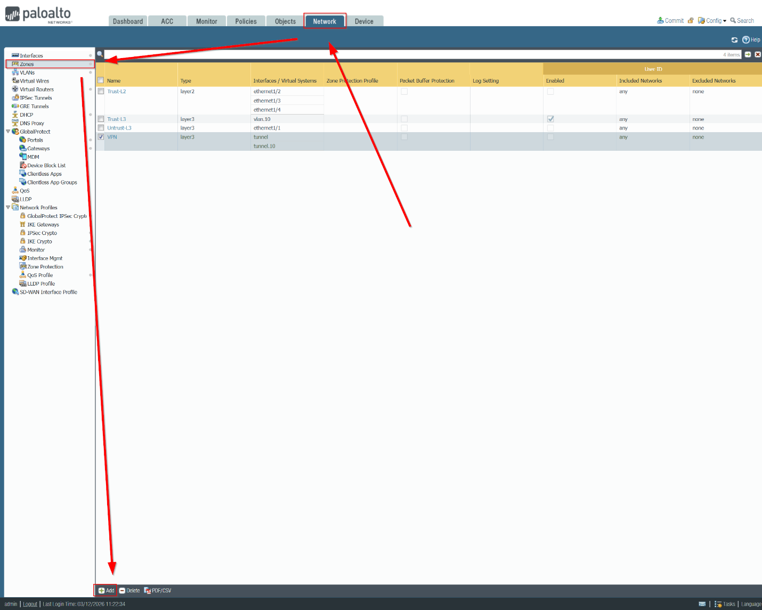

Next, configure these zone configurations and press OK.
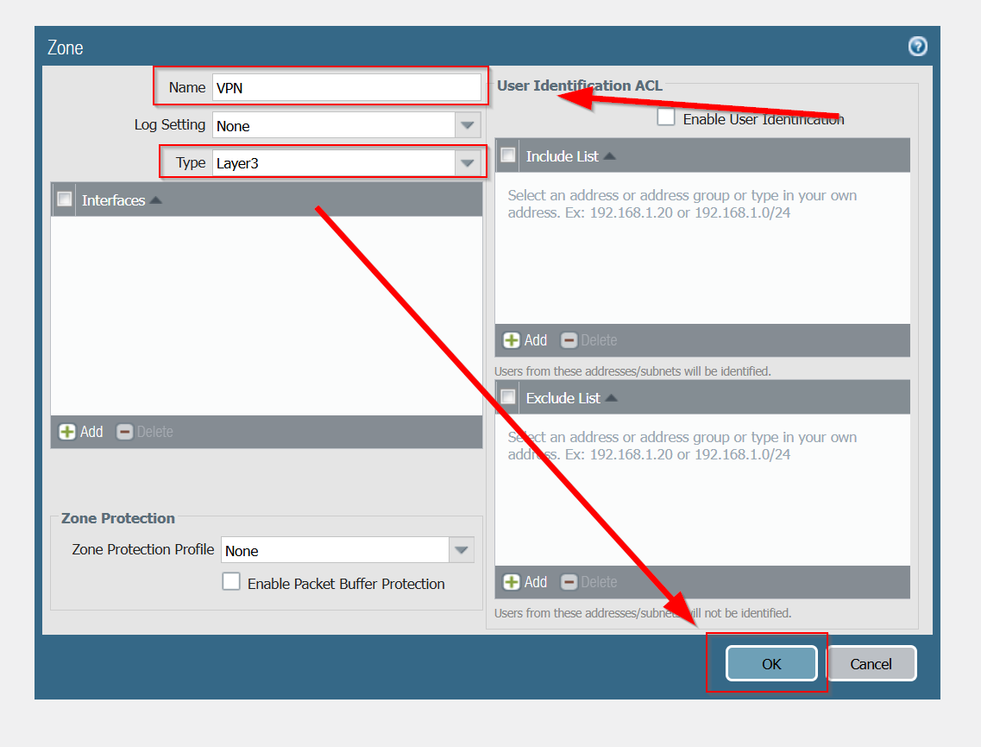

Next, to enable tunneling, go to Network -> Interfaces -> Tunnel -> click on tunnel.10.
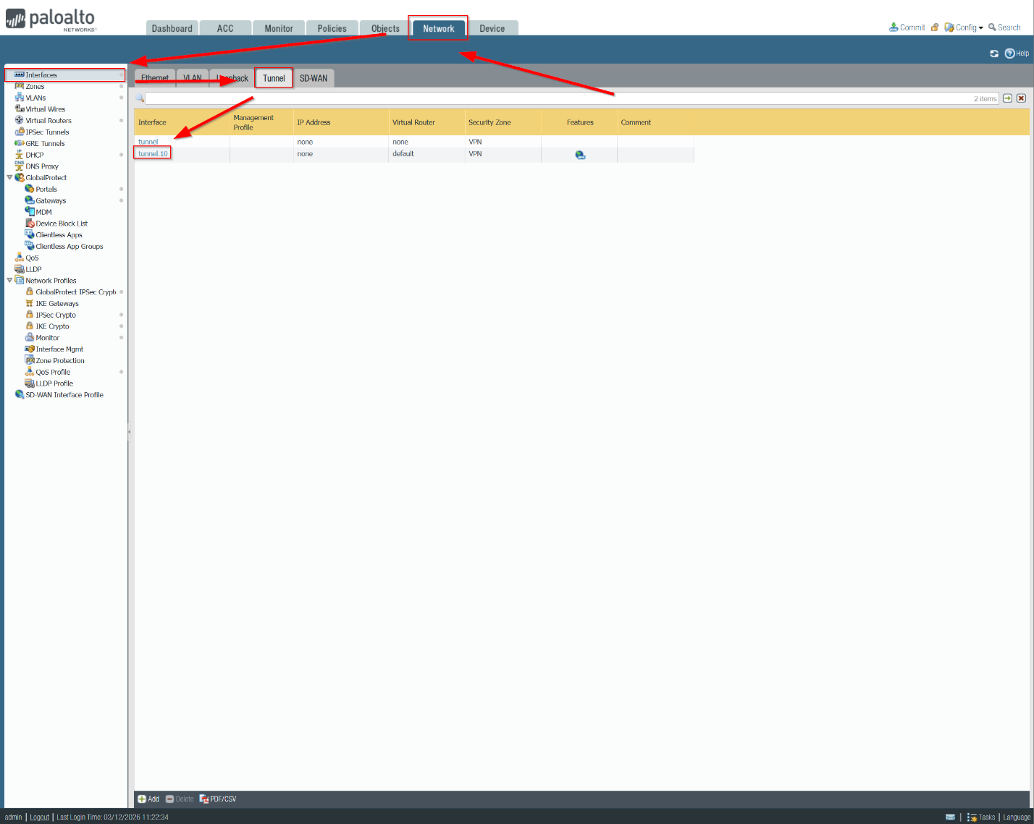

Next, assign the tunnel to the VPN Zone that we just created. Copy the configuration below and click OK to finalize your configuration.
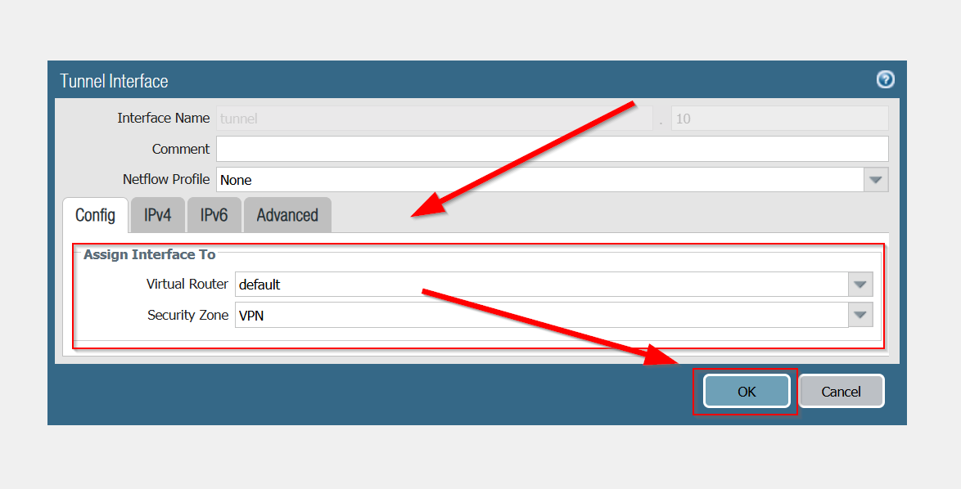

Next, to actually configure GlobalProtect Portals, head over to Network -> Portals -> Add.
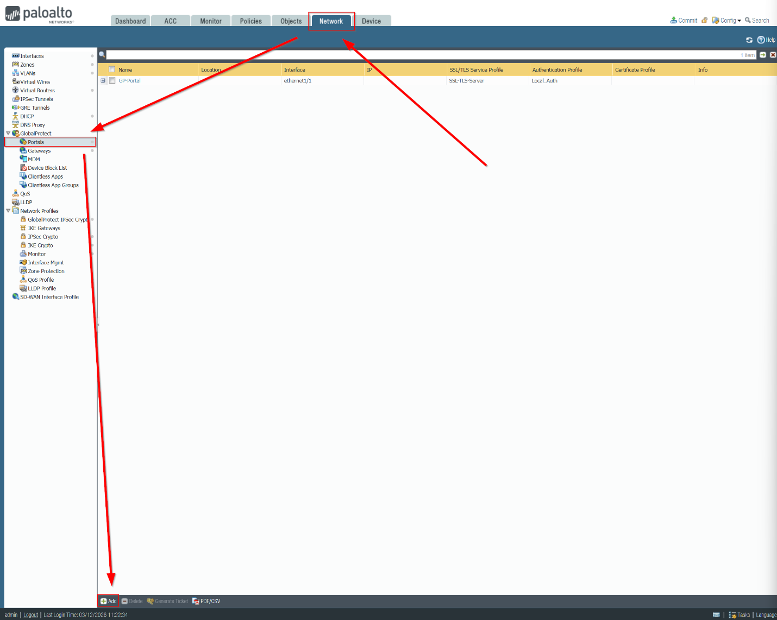
Name your GlobalProtect, and configure it to the configuration below. Then, click Authentication.
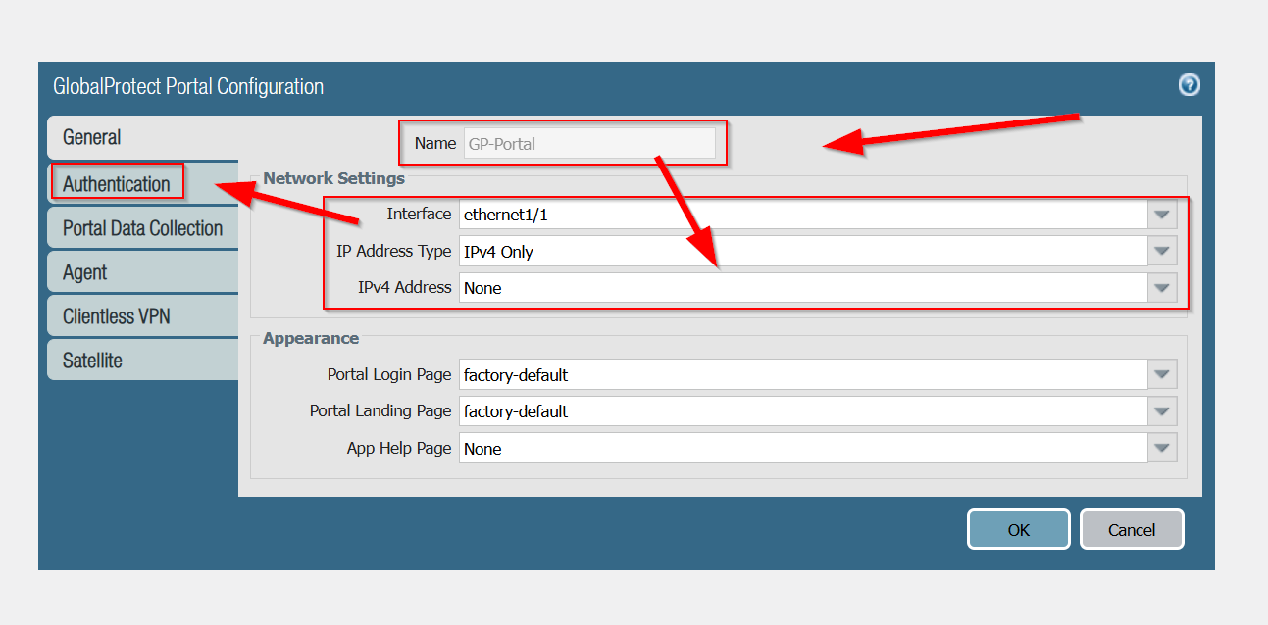
Next, select SSL/TLS Service Profile and select SSL-TLS-Server service to encrypt data. Next, add the local authentication by pressing Add.
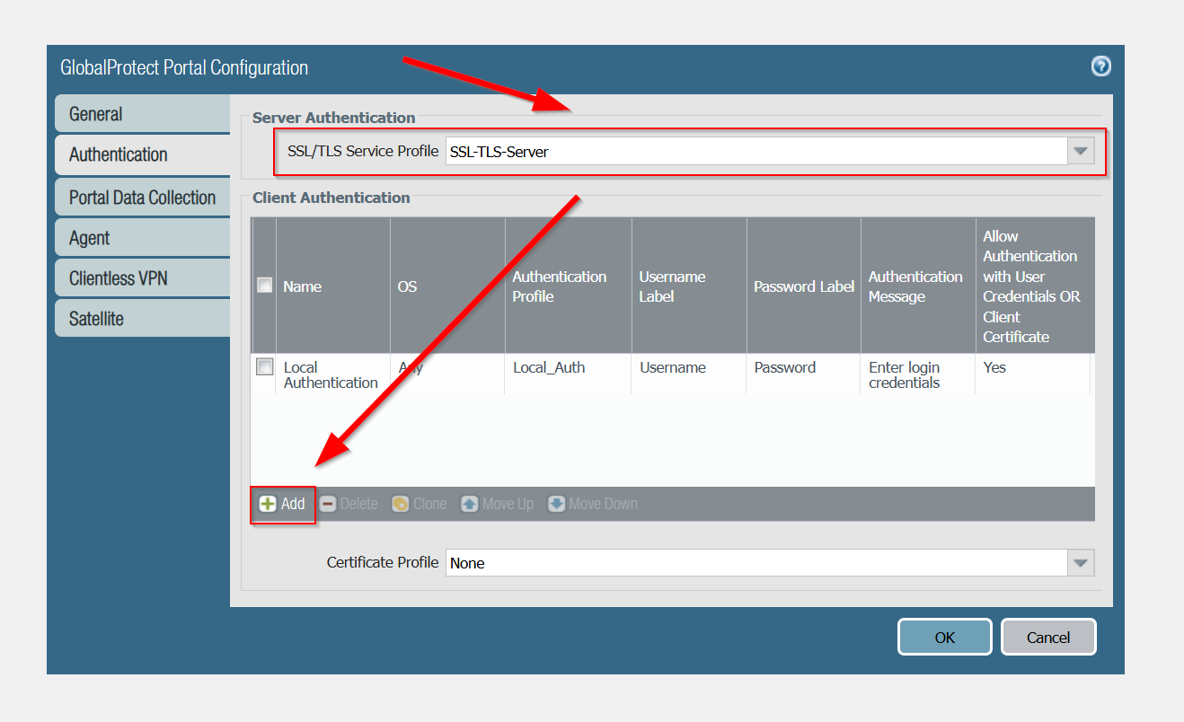

Then, name the client authentication. Select Local_Auth for the authentication profile and allow authentication with user credential or client certificate. Optionally, you can customize the GlobaProtectApp Login Screen. When you are finalized, click OK.
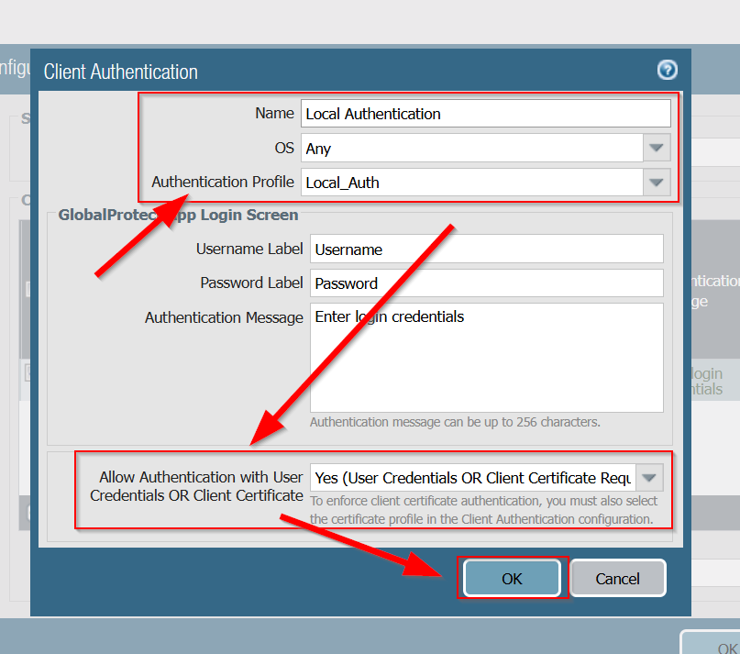

Next, click on Agent to configure the Agent settings. Add Trusted Root CA and check the boxes to utilize the certificates. Then, click add to add GP client configuration.
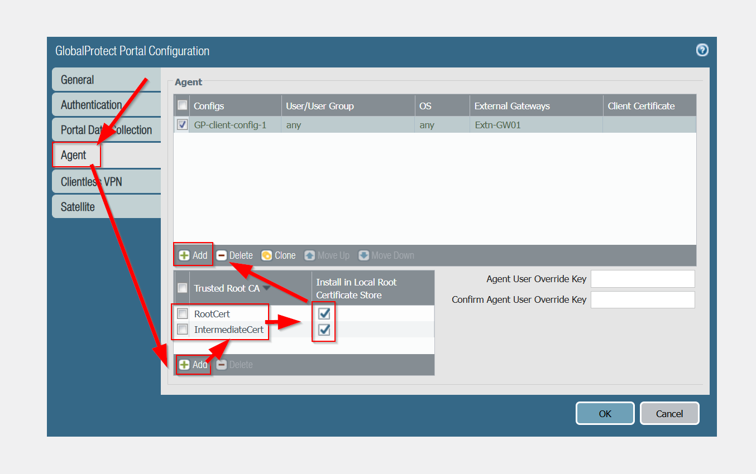

Next, name your GP client configuration. Then, put Certification to Encrypt/Decrypt Cookie as RootCert as your RSA certificate. This is crucial as it must have a private key to generate and decrypt cookie. When you are finished, press External to proceed.
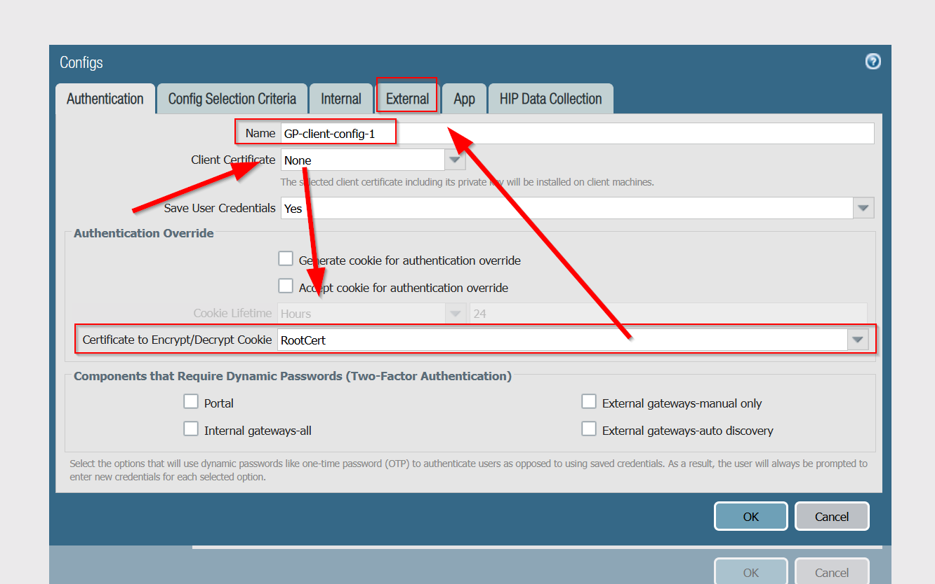

Then, press add to add the external gateway.
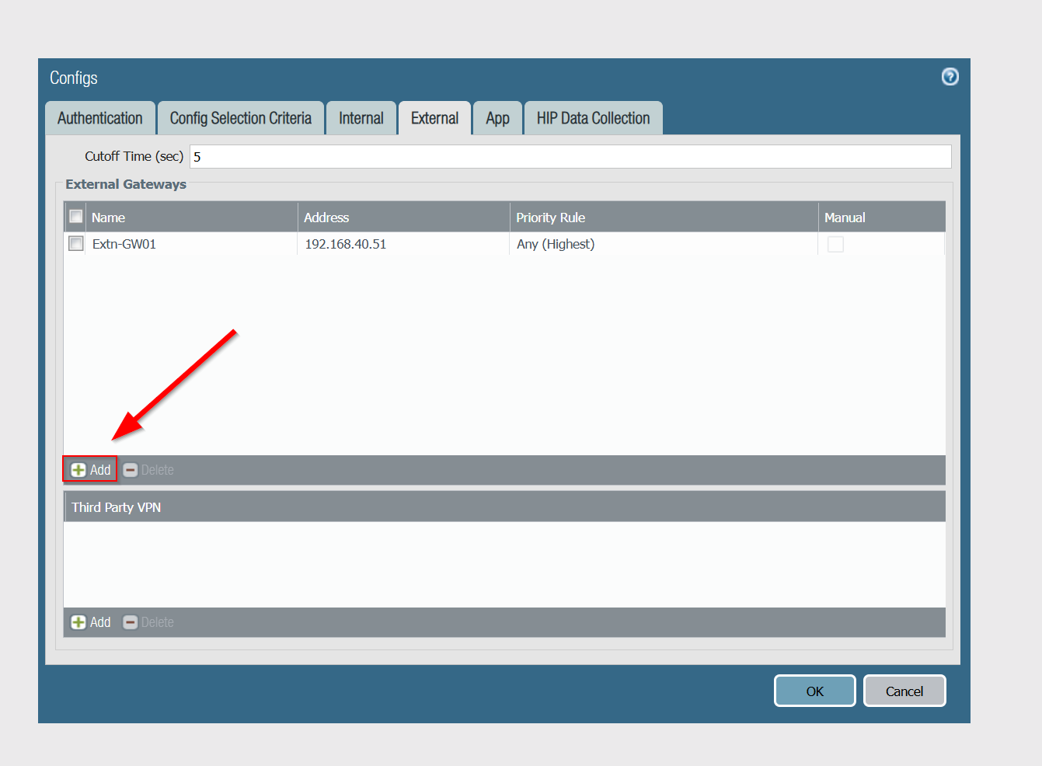

Copy the configuration below. For the IPv4, this should be your DHCP given IP Address. Once you have completed the configuration, press OK.
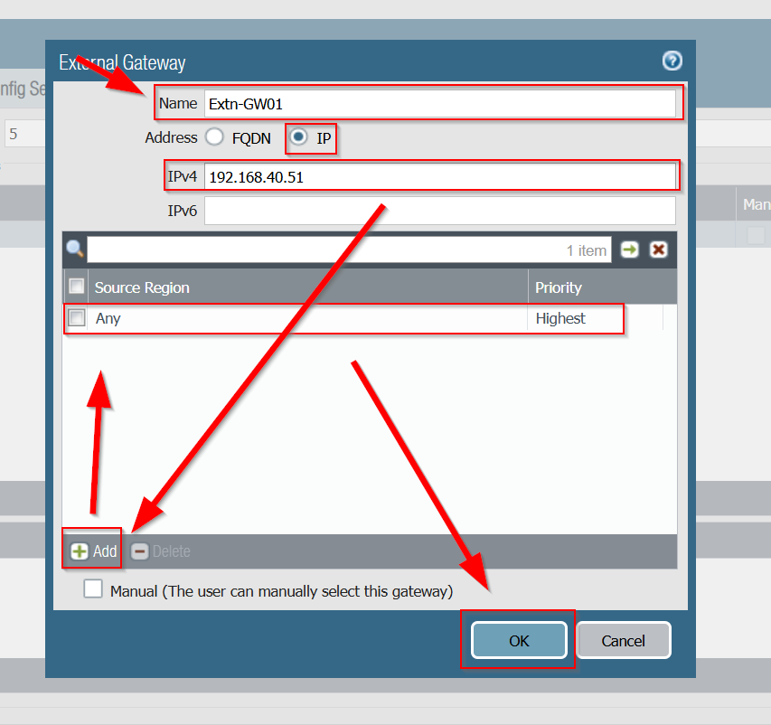

Next, head over to App and make sure these configurations are accurate.
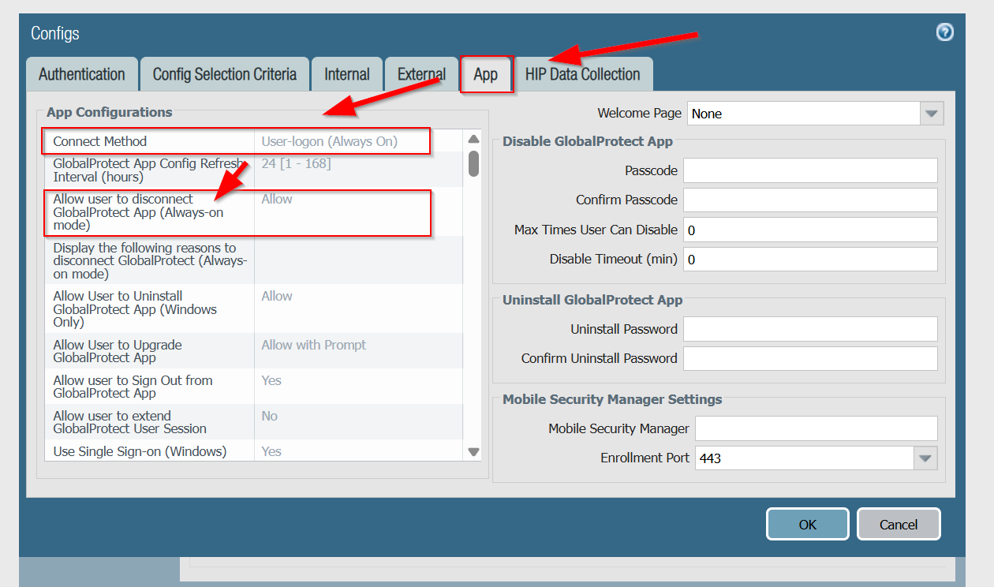
Next, scroll down and make sure this is checked as Yes. When finalized, press OK.

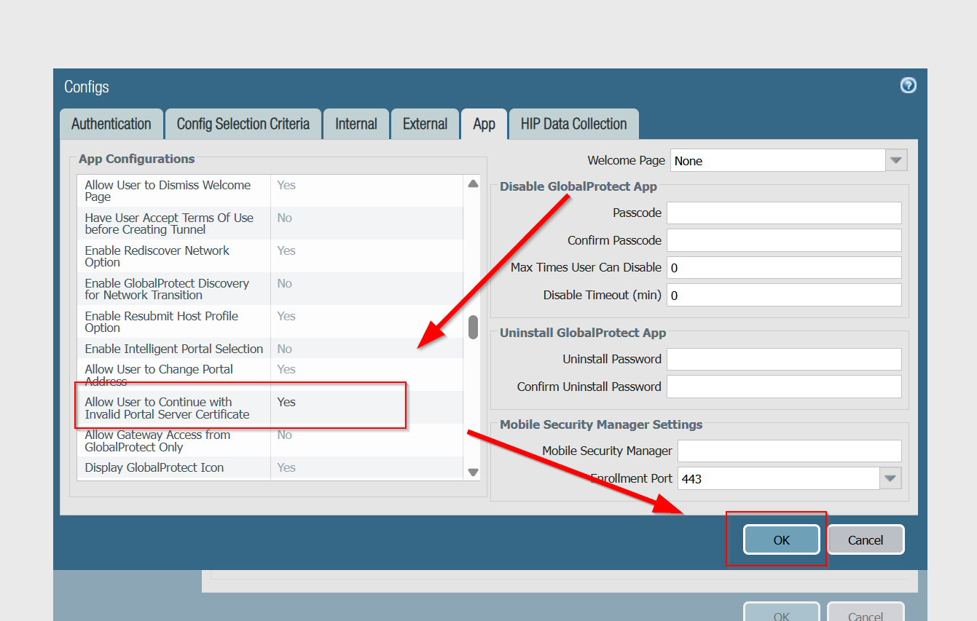

Then, to configure out GlobalProtect Gateway, go Network -> GlobalProtect -> Gateways -> Add.
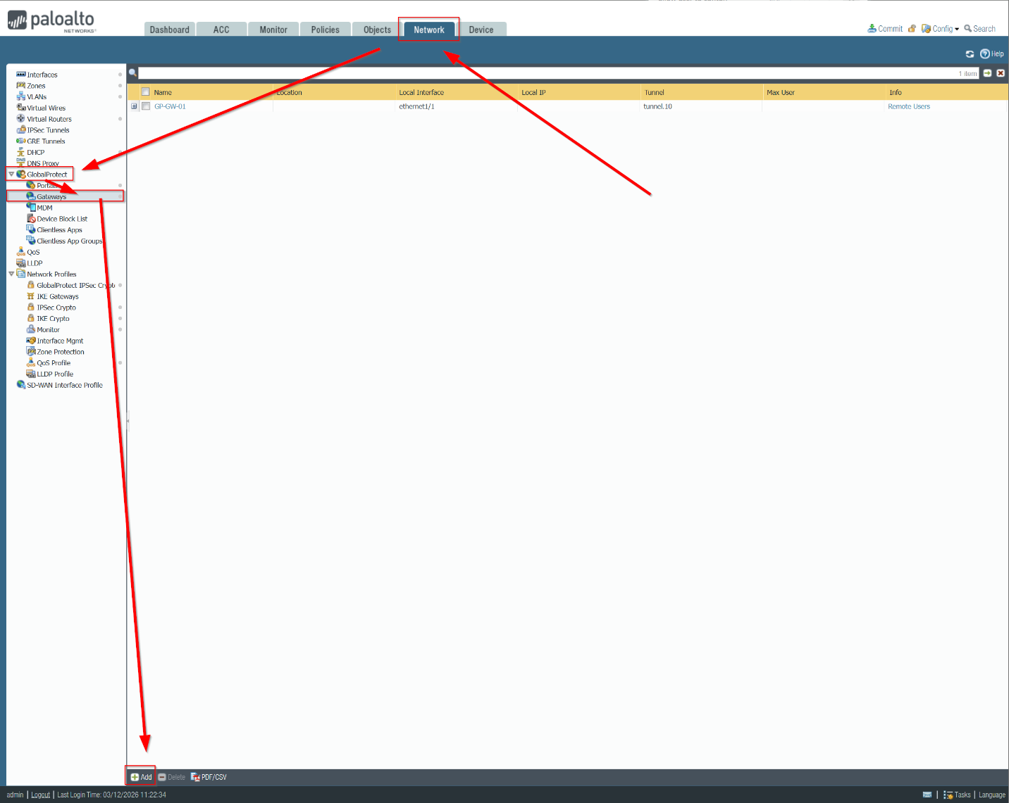

Here, name your GlobalProtect Gateway. Then, copy these network settings like GlobalProtect portal and click on Authentication when done.
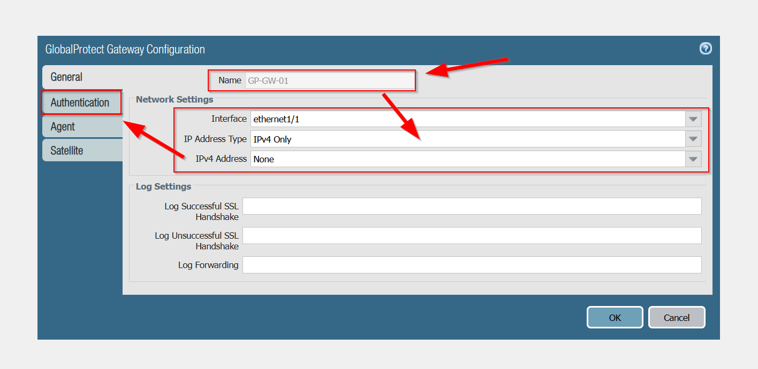
To encrypt traffic for authentication, use the SSS-TLS-Server that we have established. Then, press add to add a GlobalProtect Gateway Authenticator Local.
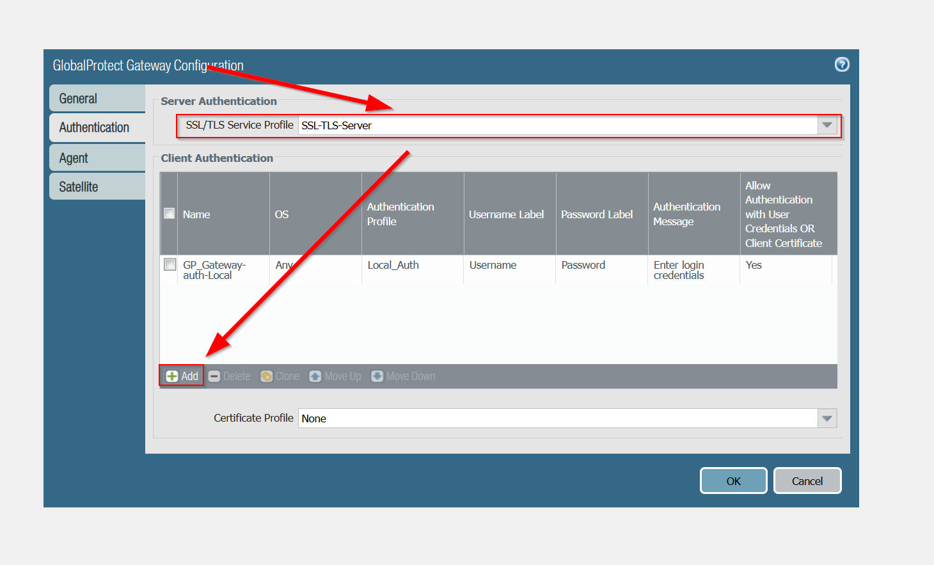

Name your GP Gateway Authenticator Local. Then, select Local_Auth for Authentication Profile. Make sure to allow authentication with user credentials or client certificate and press OK.
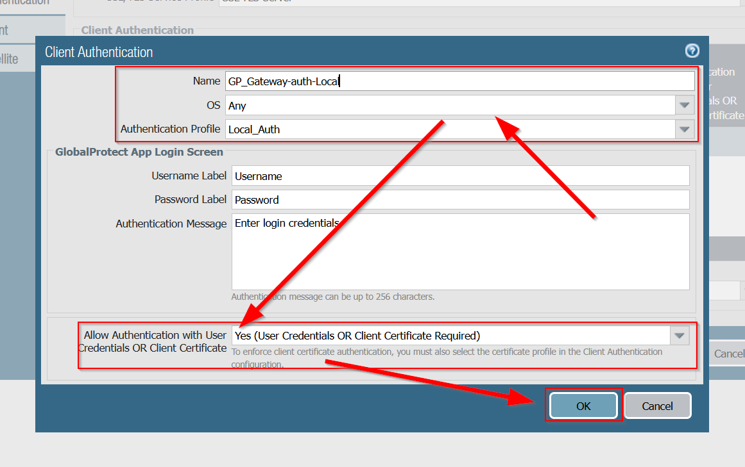
Next, navigate to Agent -> Tunnel Interface tunnel.10 -> Enable IPSec -> then Client Settings. IPSec allows secure internet communication by authenticating and encrypting each IP packet via data stream.
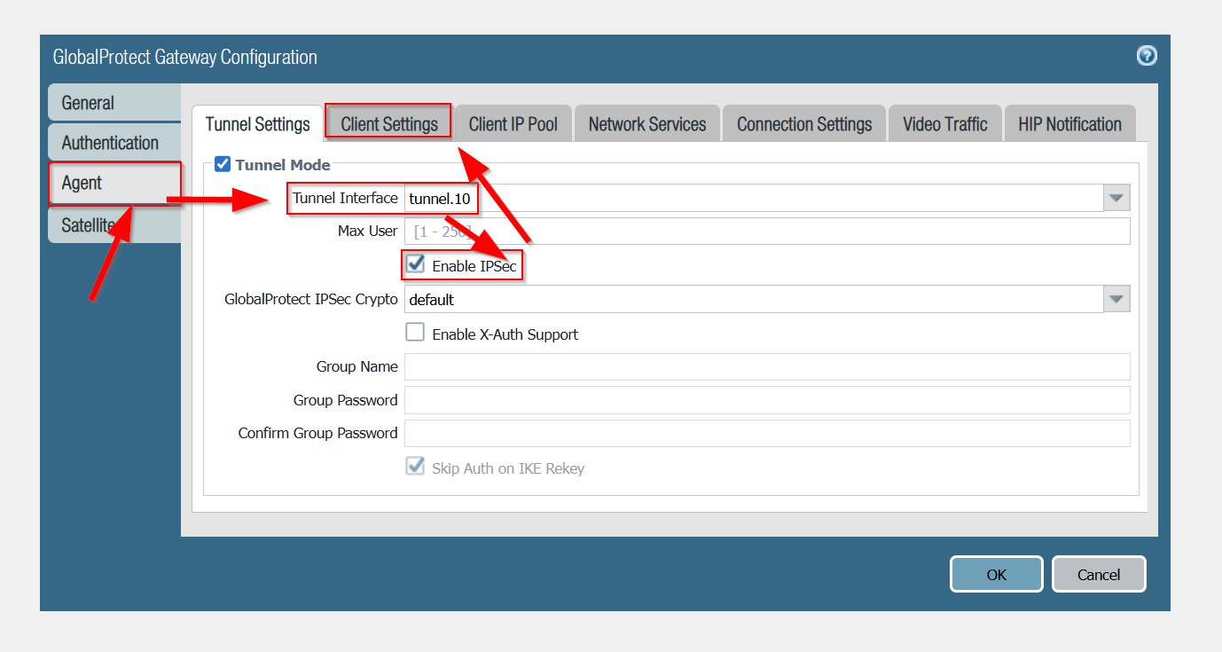

Then to add the client configuration for GlobalProtect, select Add.
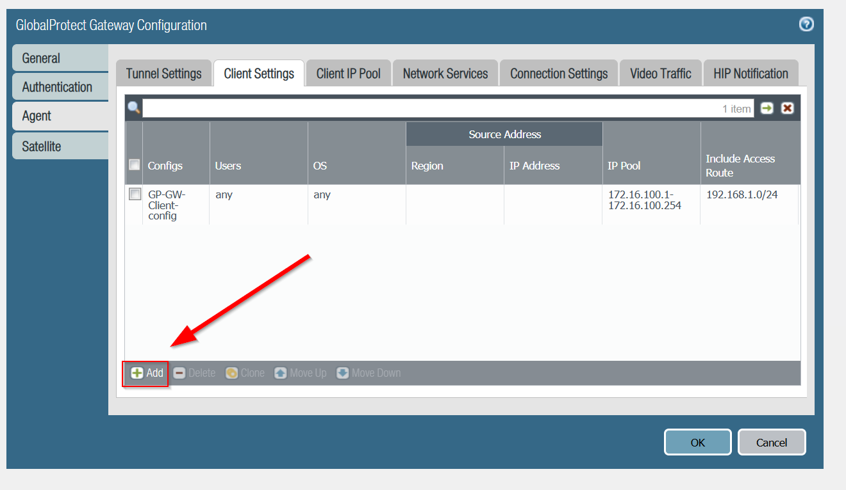

Then, name your client configuration. Then, make sure the configuration are as follows and go to IP Pools.
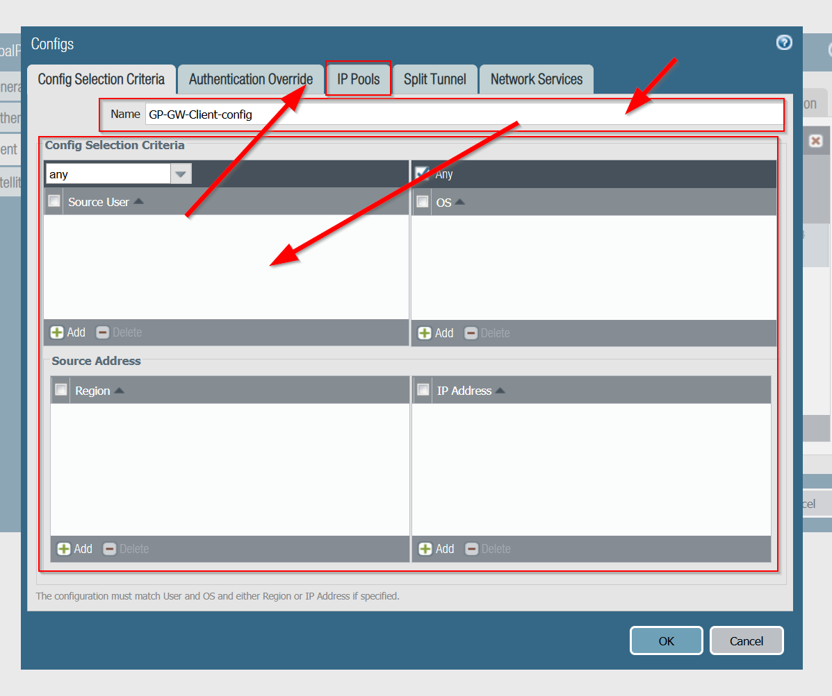

Then, put the GlobalProtect IP Pool distribution to 172.16.100-1-172.16.100.254 and click Split Tunnel.
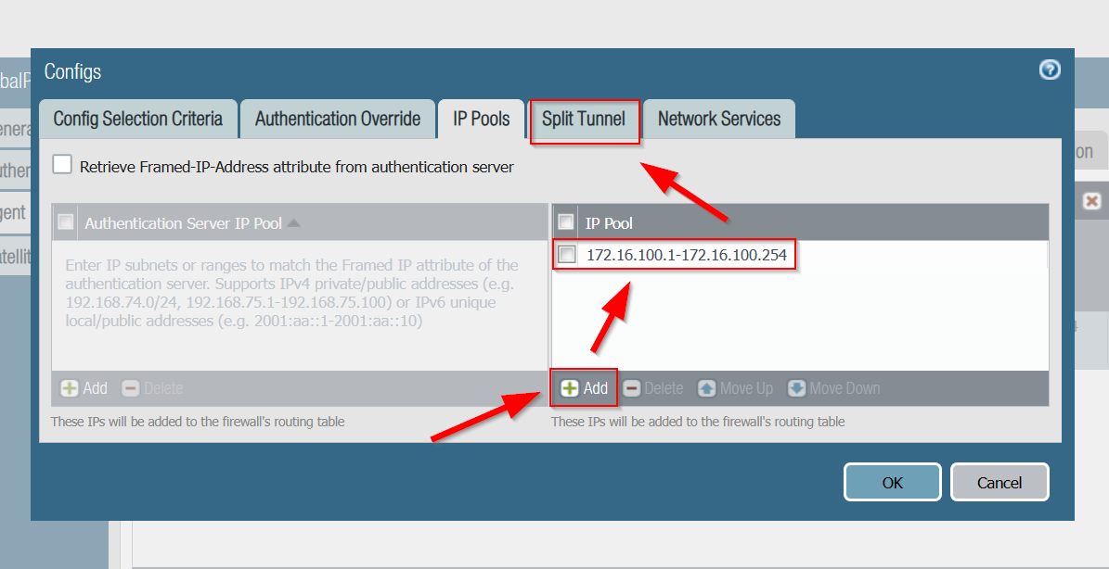
To configure split tunneling to split internet traffic into encrypted VPN tunnel and direct internet connection. In this case, 192.168.1.0/24. Once you are done, press OK.
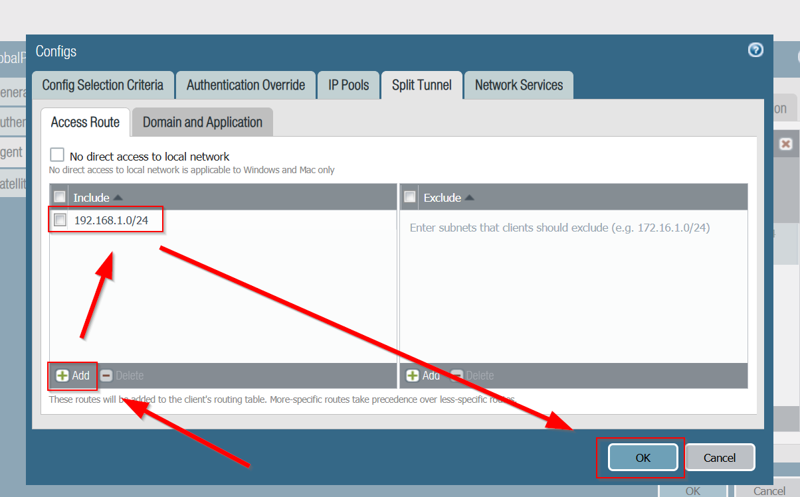

Once you are done with the whole GlobalProtect Gateway Configuration detailed above, press OK.
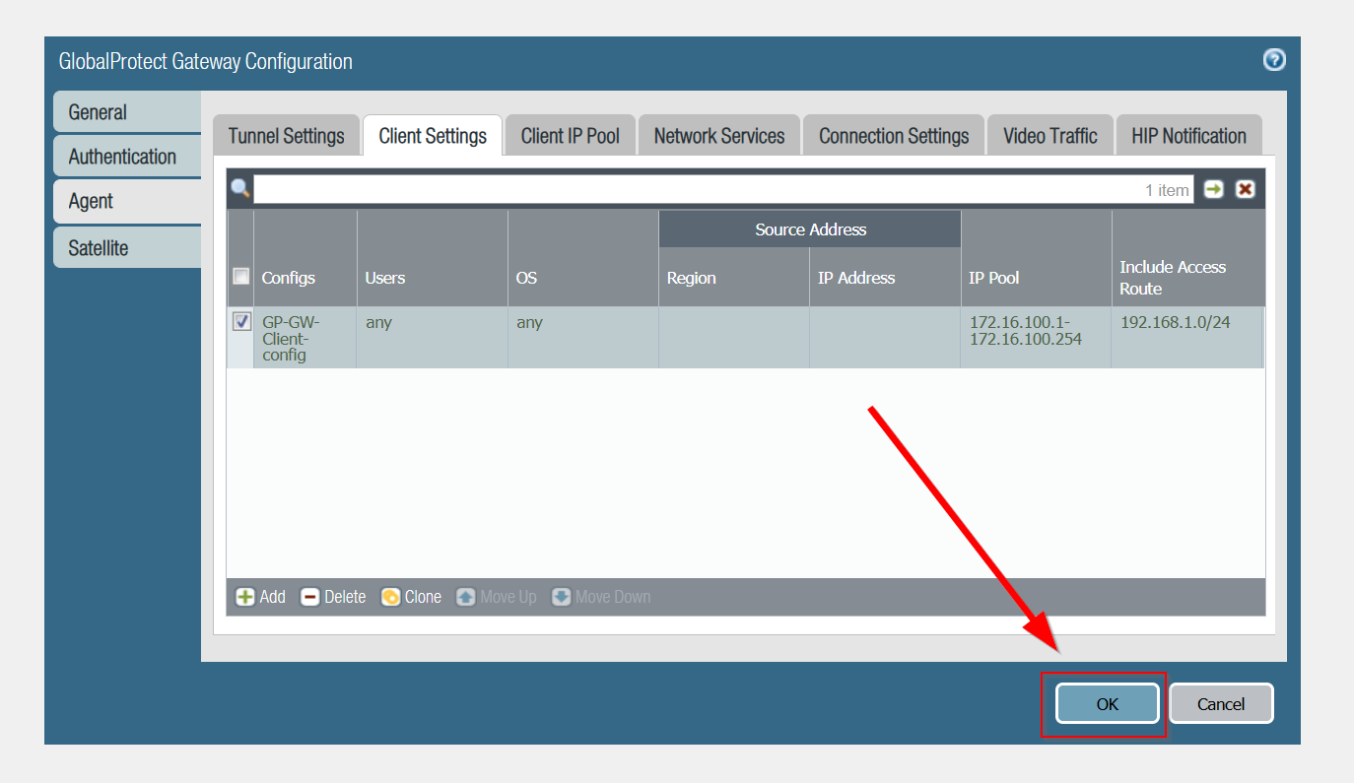

Head over to Device -> GlobalProtect Client and download the most recent version.
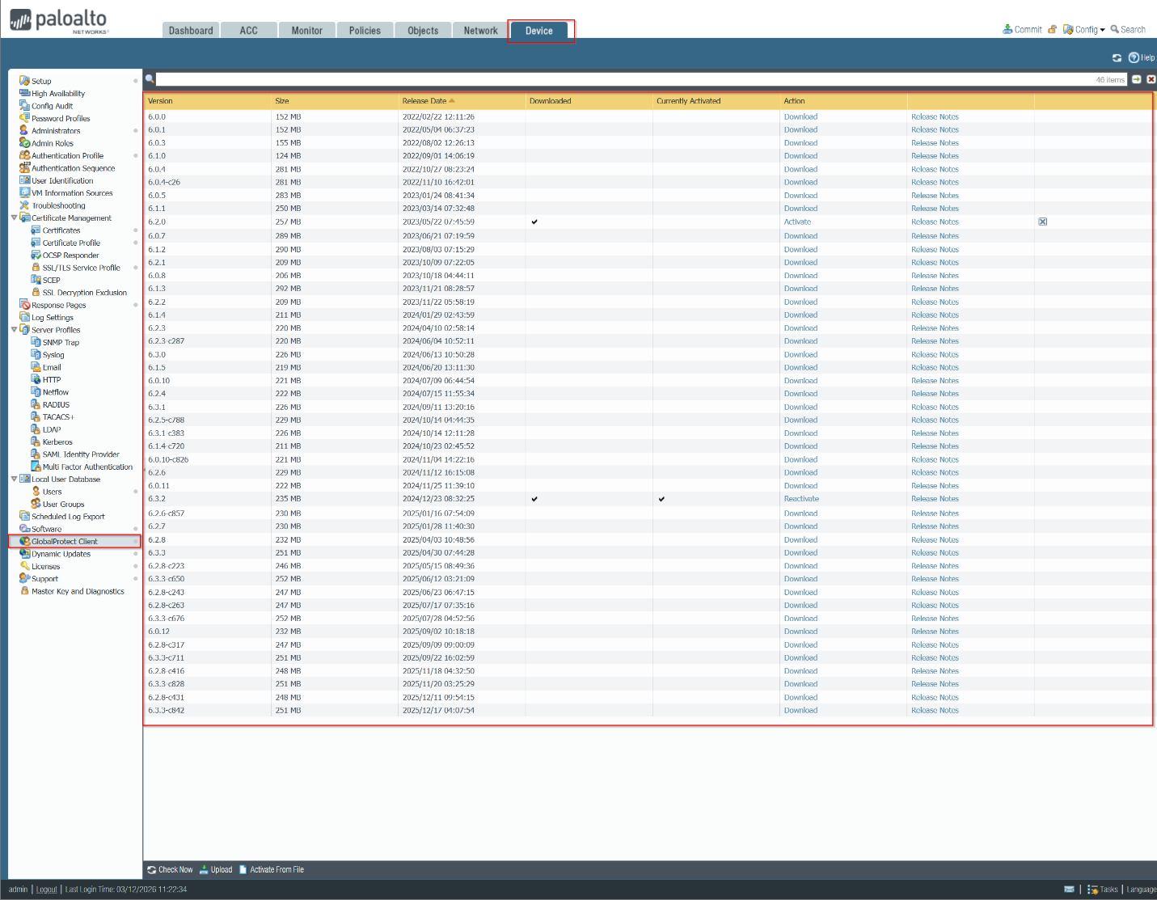

Once you have downloaded GlobalProtect, we can start remote access using VPN. Head over to PC2 and go Settings -> System -> Remote Desktop and enable Remote Desktop.
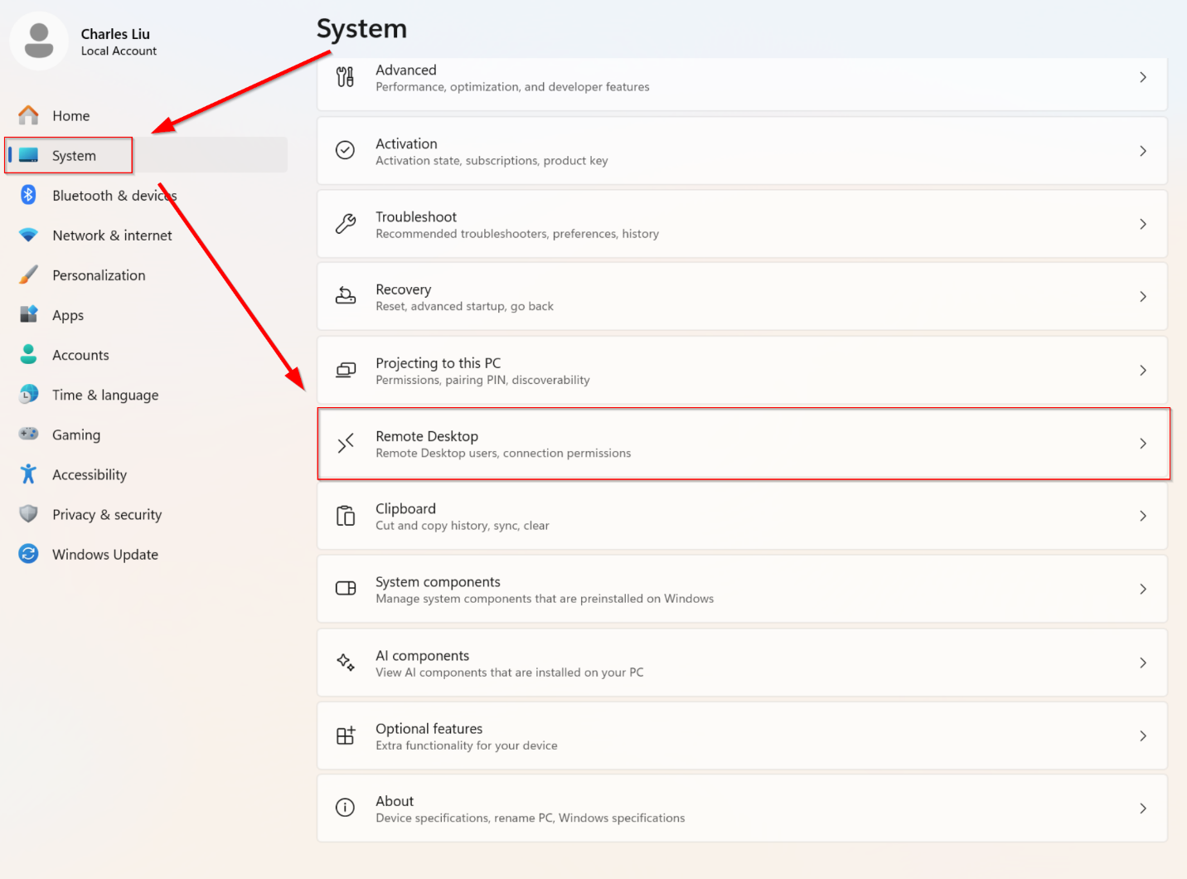
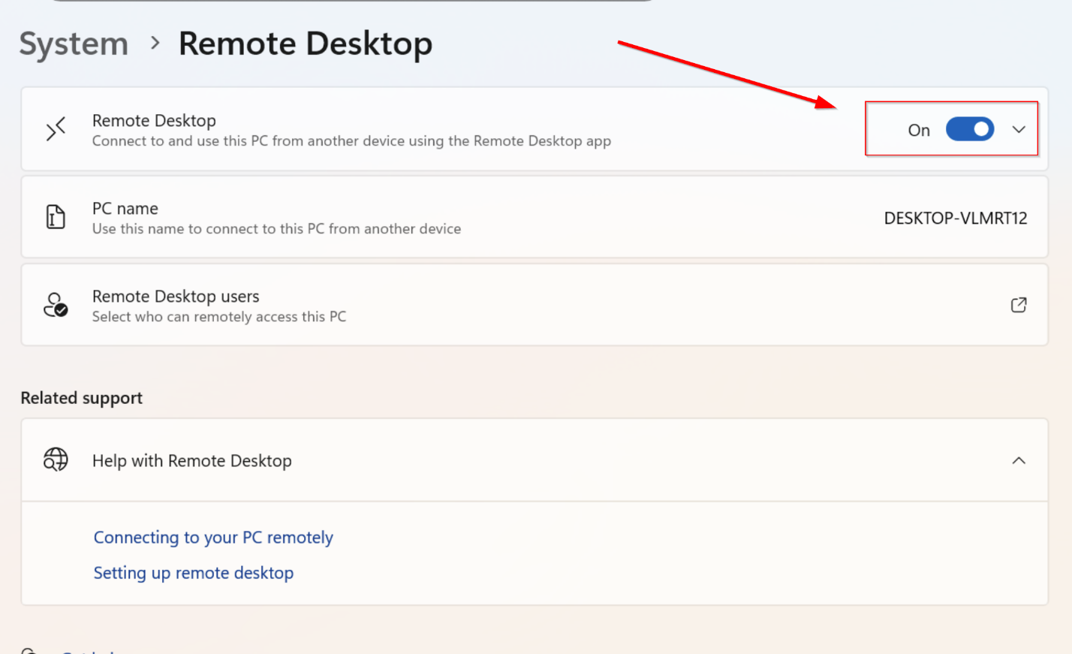

Next, on PC1, follow similar steps but select users that can remotely access the PC. Add your PC name to the list.
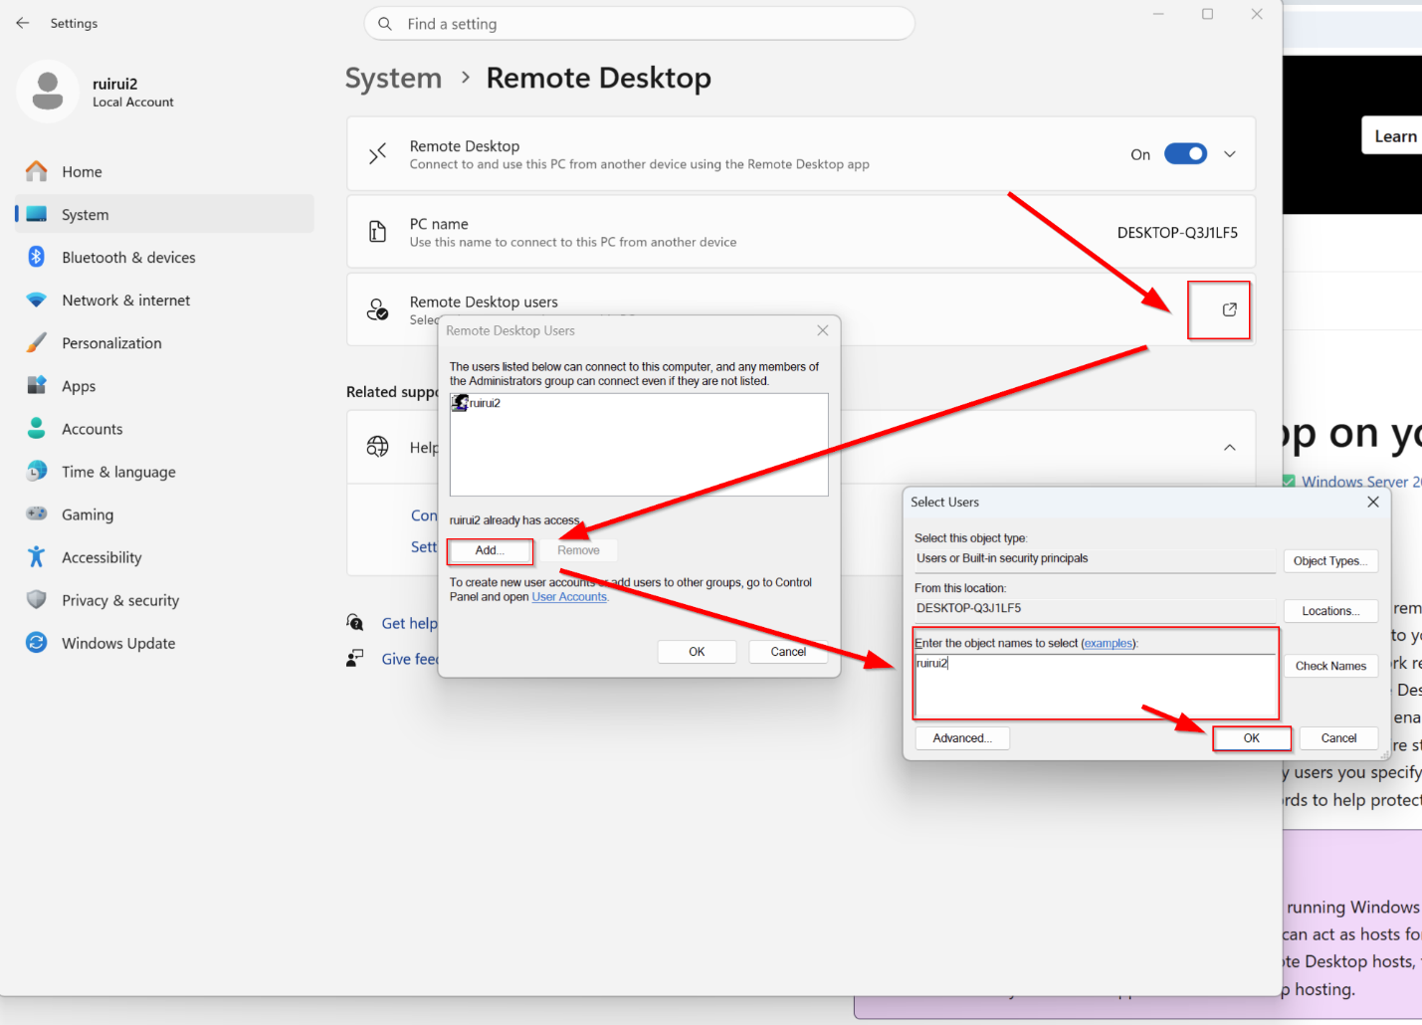

Next, go back to PC2 and click on GlobalProtect on the lower right corner. Then, select the portal with our DHCP given IP address and press Connect.
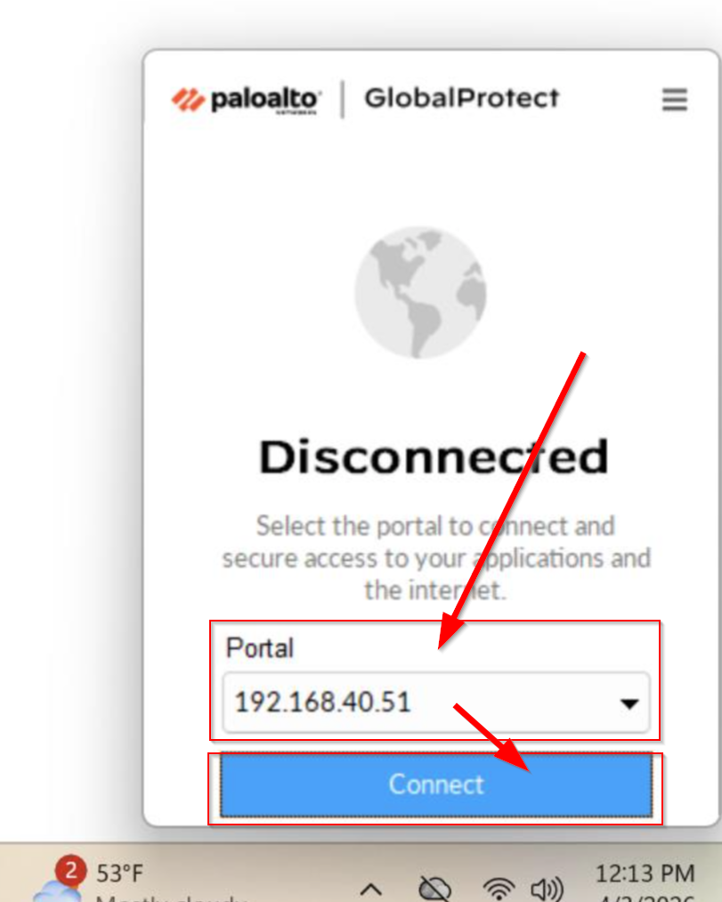

Next, access the settings by clicking on the three lines -> Settings.
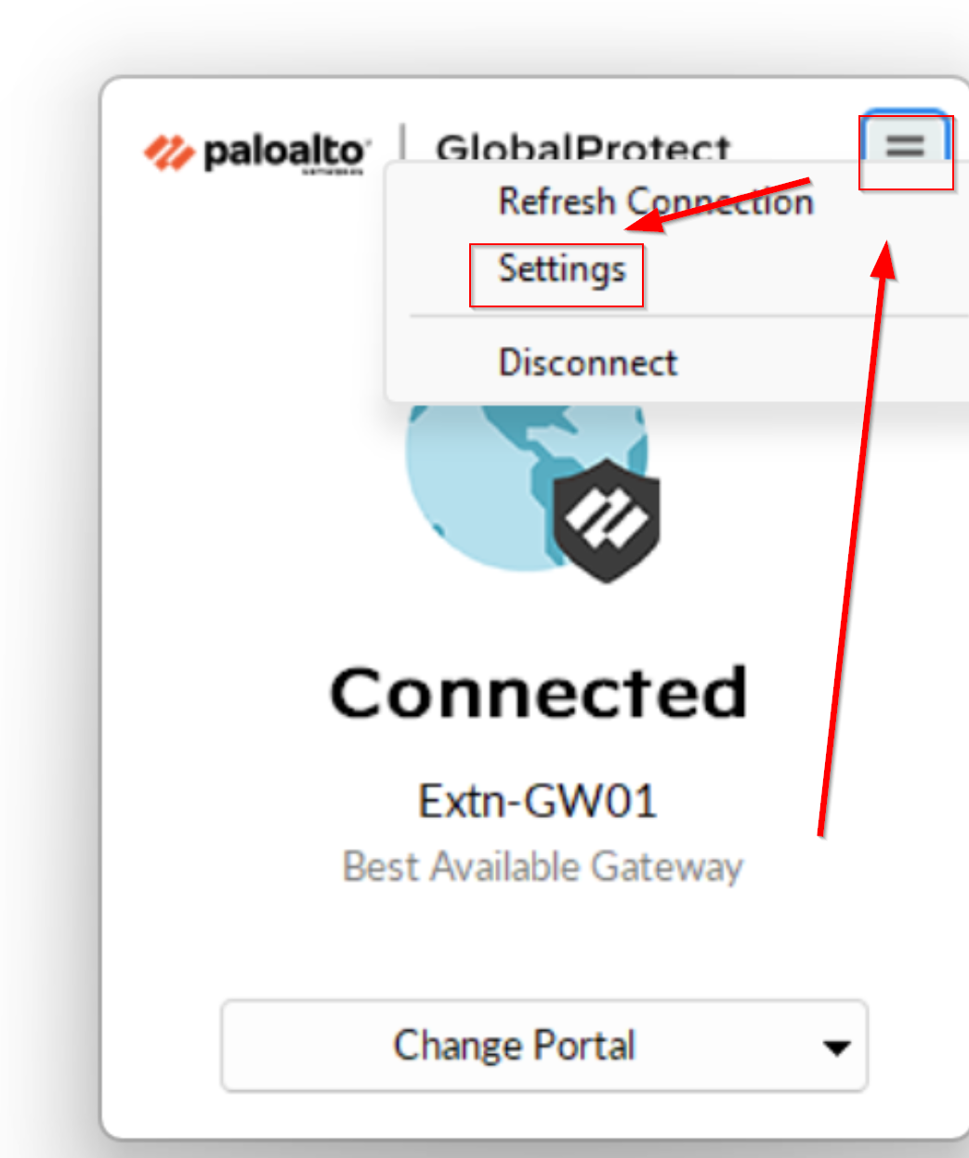
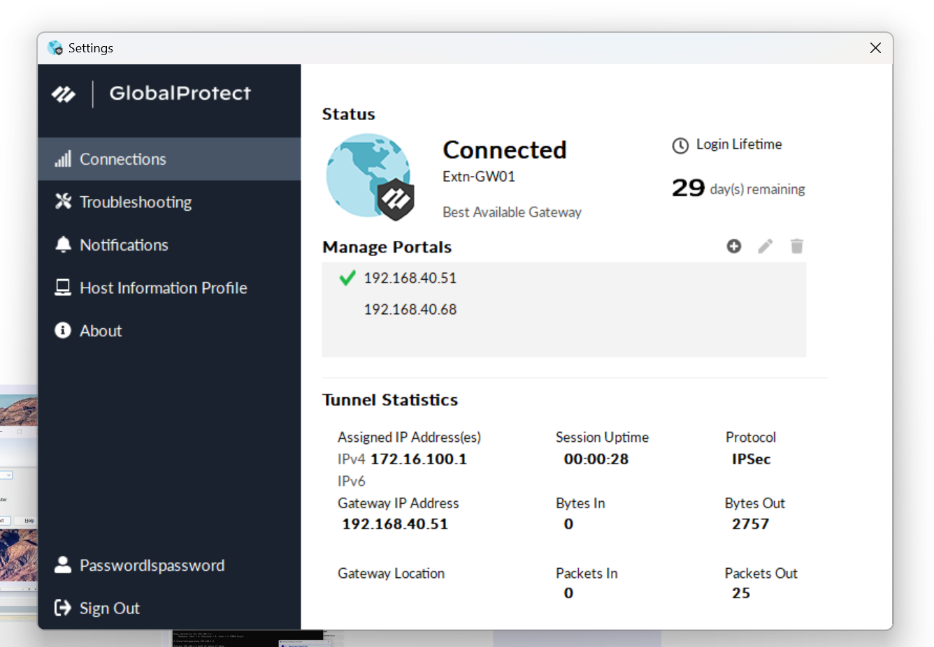

Congratulations, GlobalProtect is successfully created. Next, to remotely access PC1 from PC2, search for Remote Desktop Connection.
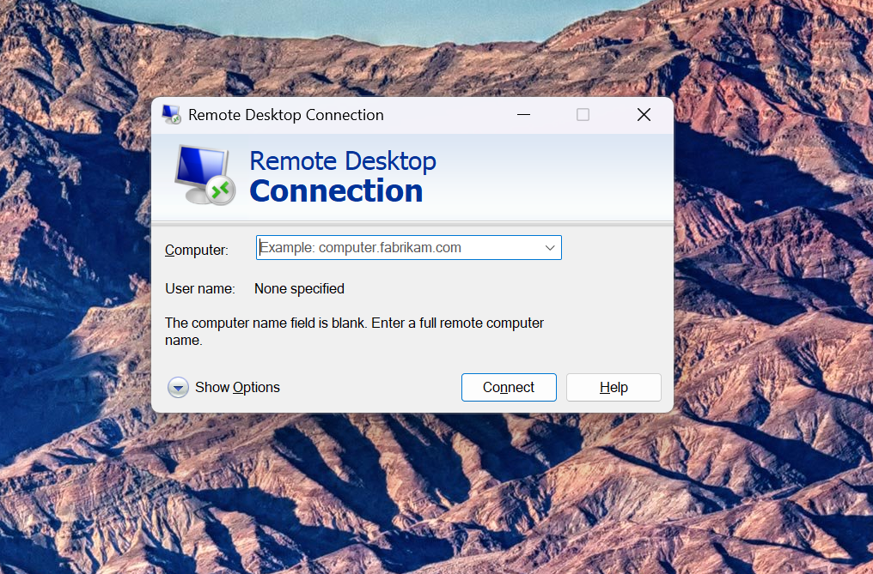

Enter in the IP address for PC1 and its User name and press Connect.
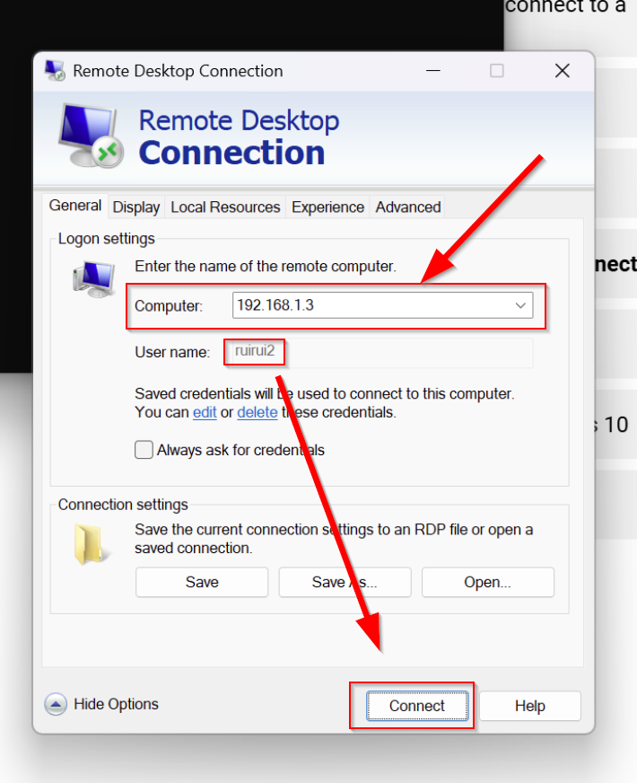

Screens should go black. Wait a little and PC2 should be in PC1’s screen, granting full control of PC1. If PC1 looks like this and you can access PC1 on PC2, you have successfully remotely connected from one device to another!

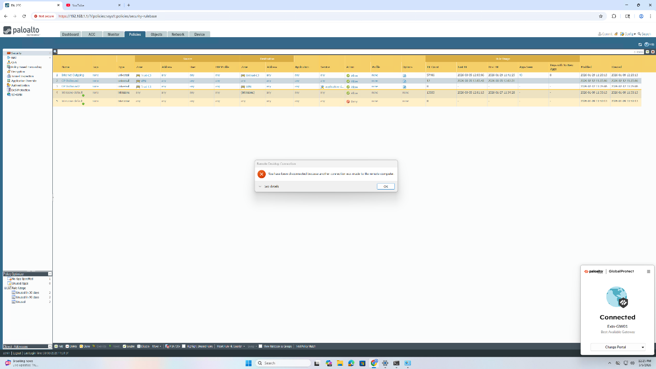

Problems:

One problem that we encountered in this lab was the outdated instructions, namely regarding certificate creation and missing VPN zones. Without VPN zones, we couldn’t segment VPN traffic based on their trust level with the correct tunnel, resulting in no real traffic at all processed. Without proper direction, we were left to research the pieces in the gap between instruction points which risks the lab because we could be configuring something entirely wrong.

Another problem was certificate creation. Unfortunately, our lab rack is shared between three groups of people at different times. One crucial problem was that the assigned DHCP address kept changing because other people were unplugging our ethernet cables, resulting in automatic renewal of DHCP IP addresses. This messes up with our certificates, which relies on a singular permanent DHCP IP address. This problem was then resolved by generating new certificates and replacing our old certificate references with the new ones. This is important because many places feature certificates, including GlobalProtect Portal, SSL, and more.

Furthermore, similar to the second problem, our PC’s 10GB cable was always unplugged right after we left. This results in the constant disconnection from our PC to our firewall. Since we didn’t know the root cause, we couldn’t log in and had to spend days tracing the problem, including power cycles. While we do not know the root cause or intentions of the person unplugging our 10GB cable, it was then that we learned/were reminded that the 10GB cable actually existed in the first place.

Conclusion:

In conclusion, this lab provided hands-on experience with setting the VPN up for remote access, as well as learning just how important an effective VPN is for an enterprise. The problems encountered in this lab allowed me to discover solutions that were not provided, and brainstormed processes of steps and reasoning behind the configuration of this firewall. I’m sure that I can apply this knowledge into the real world, where I can incorporate these skills into a professional environment.

